Project Status Report

数字校园

V 1.0

Erin Wang
Project Manager



Aug 16, 2001

Document Control

Change Record

Date | Author | Version | Change Reference
8/16/2001 | Erin Wang | V1.0

Reviewers

Date | Name | Position
8/17/2001 | John, Erin

Approved By

Name | Position | Signature | Date
The copy numbers referenced above should be written into the Copy Number space on the cover of each distributed copy. If the document is not controlled, you can delete this table and the Copy Number label from the cover page.

CONTENTS

1. Customer Complains 4
2. Milestones/Tasks Achieved 4
3. Milestones/Tasks Planned for next period 4
4. Quality Assurance Activities 4
5. Issues 4
6. Number of Requirement Change Request 4
7. Major Changes from the Plan 5

Customer Complains
No teacher monitor showing system.

Milestones/Tasks Achieved
Milestones/Tasks | Status | Remark | Deliverables | Delay
Requirement analysis | Complete |  | Software requirement document | -3 days

Milestones/Tasks Planned for next period
Time: Aug16 – Aug22
Milestone: Project Planning
Deliverables:
- Software development plan
- Configuration management plan
- Software quality assurance plan

Quality Assurance Activities
QA Activity | Defects detected | Defects closed | Defects open
Requirement document review | 14 | 14 | 0

Issues
No. | Issue | Raised by | Action by | Status
1 | Whether the oracle is free | customer |  | Close
2 | The new requirement need to confirm | Erin Wang | Erin Wang | Open

Number of Requirement Change Request
Add teacher show his/her window to all students( not confirm)

Major Changes from the Plan
The SPP begins in advanced.
From Aug 16-22

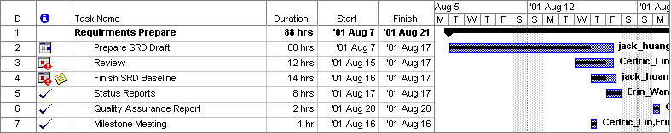
Standard Tailoring Record

Delete Item:
Item Name | Reason
Add Item:
Item Name | Reason
Modify Item:
Item Name | Reason | Modification

